**DATABASE DESIGN**

1. User Sign-Up/Sign-in

|  |
| --- |
| Customer |
| Email id  Password  Name  Gender  Contact |

2. Restaurants

|  |
| --- |
| Restaurants |
| ID  Name  Ratings  Location  Contact |

3. Cart items

|  |
| --- |
| Cart |
| Item  Quantity  Ratings  Price  Total price |

4. Food items

|  |
| --- |
| Food |
| Item  Price  Ratings |

5. Offers

|  |
| --- |
| Cart offers |
| Item  Quantity  Ratings  Price  Total price |

6. Delivery boy

|  |
| --- |
| Delivery boy details |
| Name  ID  Password  Mobile Number  Location  Vehicle Number |

7. Job seeker

|  |
| --- |
| Job description |
| Job Id  Job title  Description |

8. Admin

|  |
| --- |
| Admin sign in |
| Id  Password |

**Architecture Diagram:**

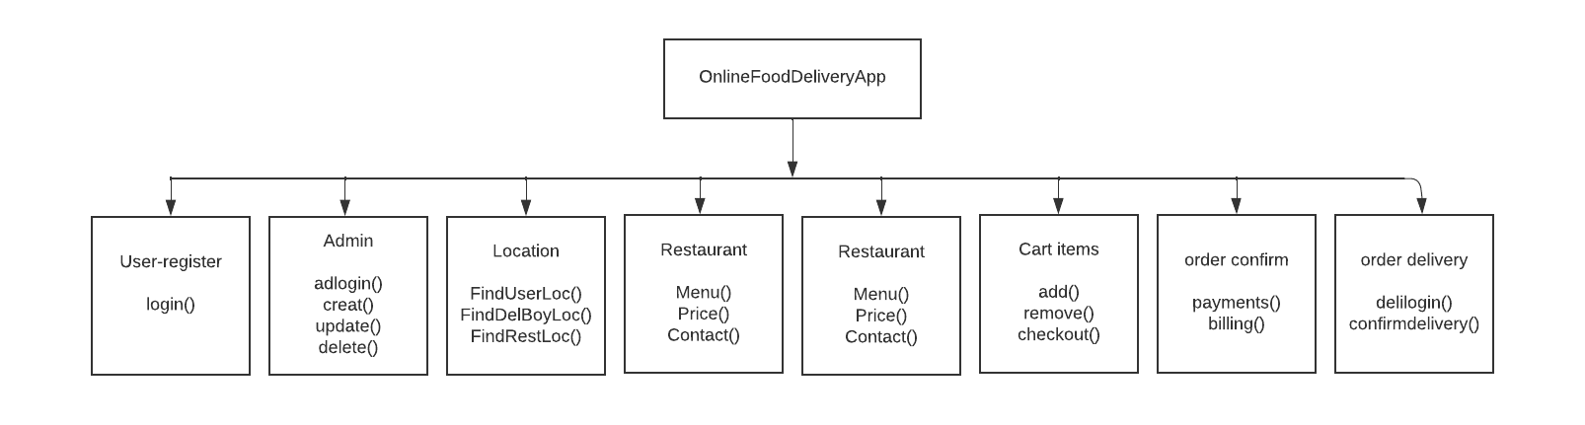

**UML Diagram**

1. Order Portal

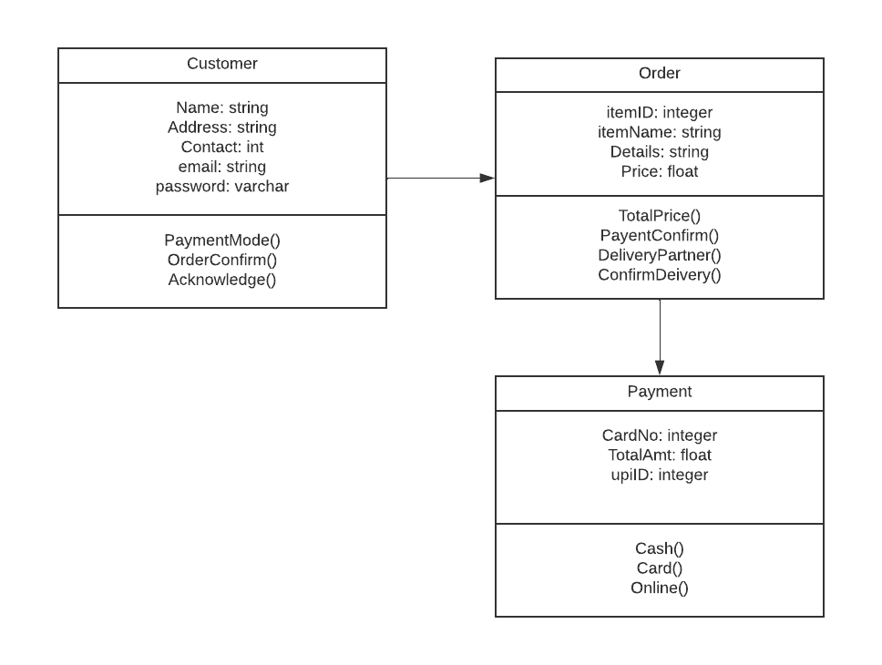

2. Delivery Portal

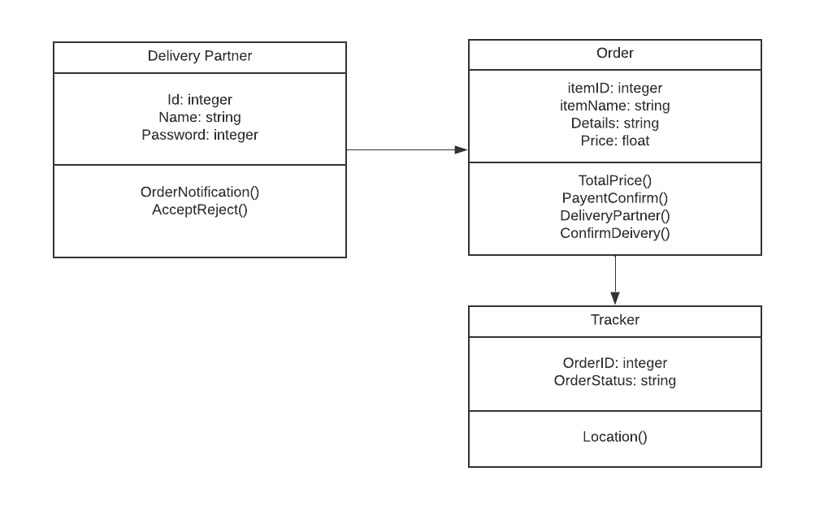

**Activity Diagram:**

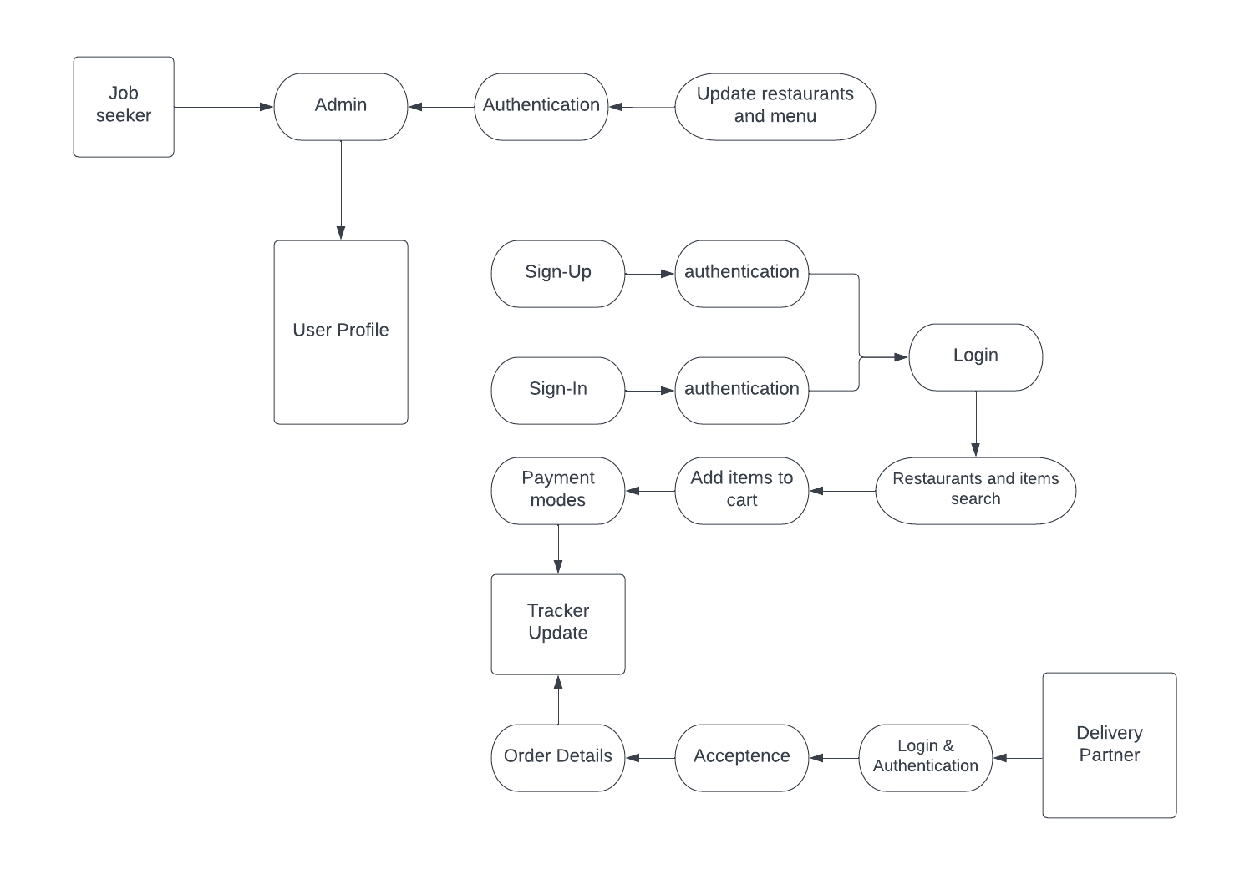

**User-Case Diagram:**

